

**Data Analytics**

**Assignment - 1**

Dharmesh Harsha (ESD15I018)

Akshay Kumar (CED15I031)

Vivek Khatua (MFD15I014)

Our product is essentially a wearable smoking cessation device which help smokers quit smoking effortlessly. It basically has 3 parts:

* Sensing data
* Mobile App
* Drug delivery

It uses various **data analytics** and **machine learning techniques** for a overall main goal to predict, **individual’s nicotine craving pattern** throughout the day. This helps in implementing the already existing therapy in much more efficient manner.

**Note: This is our conceptual product which is in prototyping phase.**

### Data Acquisition:

Our product will have 3 main sensors, i.e. Temperature sensor, Pulse rate sensor, Carbon monoxide sensor, which will work as the primary source of data for our analysis. Also we will be accessing other data like location, weather in surrounding, etc. which we will collect through the mobile.

All these various parameters are the main data set.

### Data Analytics:

To help patients fight nicotine addiction, the system provides real-time analytical feedback. The data acquired from the above mentioned sensors and user feedback via app is used to make the following inferences, decisions, and predictions.

### Features:

1. **Prediction**:
   1. Nicotine craving Pattern:

Based on the predicting algorithms, the device will trigger the drug delivery system.

* 1. Nicotine Level in the blood

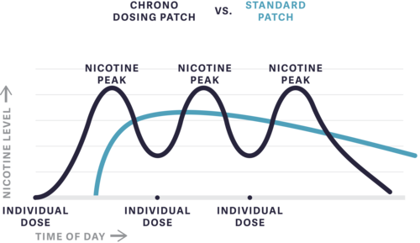

**Our Product** Vs **Nicotine Patches**

* 1. Heart Attack Alert:

Based on the pulse oximeter readings and previous heart attack records, the device will learn and alert the patients for tentative heart attacks

1. **Descriptive** Summary smoking pattern (daily basis):
   1. No. of cigarettes consumed

Based on the temperature changes of the skin with time, the device can estimate the no. of cigarettes consumed by the patient.

1. **Inferential** Analysis:
   1. Reminder System for drug refill
   2. Alert for extra support
2. **Clustering** based on location of individual:

Based on the location (x,y) wrt to home (origin) of smoking by the patient, the device will cluster the location points. This in return will help in better prediction of individual’s nicotine craving.

### References:

* <https://www.ncbi.nlm.nih.gov/pmc/articles/PMC5161415/>
* <https://www.ncbi.nlm.nih.gov/pmc/articles/PMC5003586/>
* <https://www.chronothera.com/>
* <http://www.who.int/fctc/publications/Smoke_free_policies_FINAL_09052014.pdf>
* <http://dhss.alaska.gov/dph/Chronic/Documents/Tobacco/PDF/2014_TPC_E-CigLitReview.pdf>